# UNLOCKING INSIGHTS INTO THE GLOBAL AIRTRANSPORTATION NETWORK

***1. INTRODUCTION***

***1.1 OVERVIEW***

*The Global Air Transportation Network dataset is a comprehensive collection of information on airports, airlines, and there, routes. It contains information such as names, cities, countries, codes (IATA and ICAO) longitudes, latitudes and altitudes of airports across the world with detailed time zone and daylight-saving time data. This dataset has been compiled through meticulous labor by researchers all over the world to give you a comprehensive*

*Detail into air transportation networks from around the globe.*

***1.2 PURPOSE***

*This project is used to analyze the growth of the country and the economic development of the country at the world level. This helps to find the number of airlines and number of airports at the world level. This helps in the transportation of raw materials quickly. This is one of the cheapest ways to the transportation of raw materials for the international level business. This will help to find the airport route at the world level.*

***2.PROBLEM DEFINITION AND DESIGN THINKING***

***2.1 EMPATHY MAP***

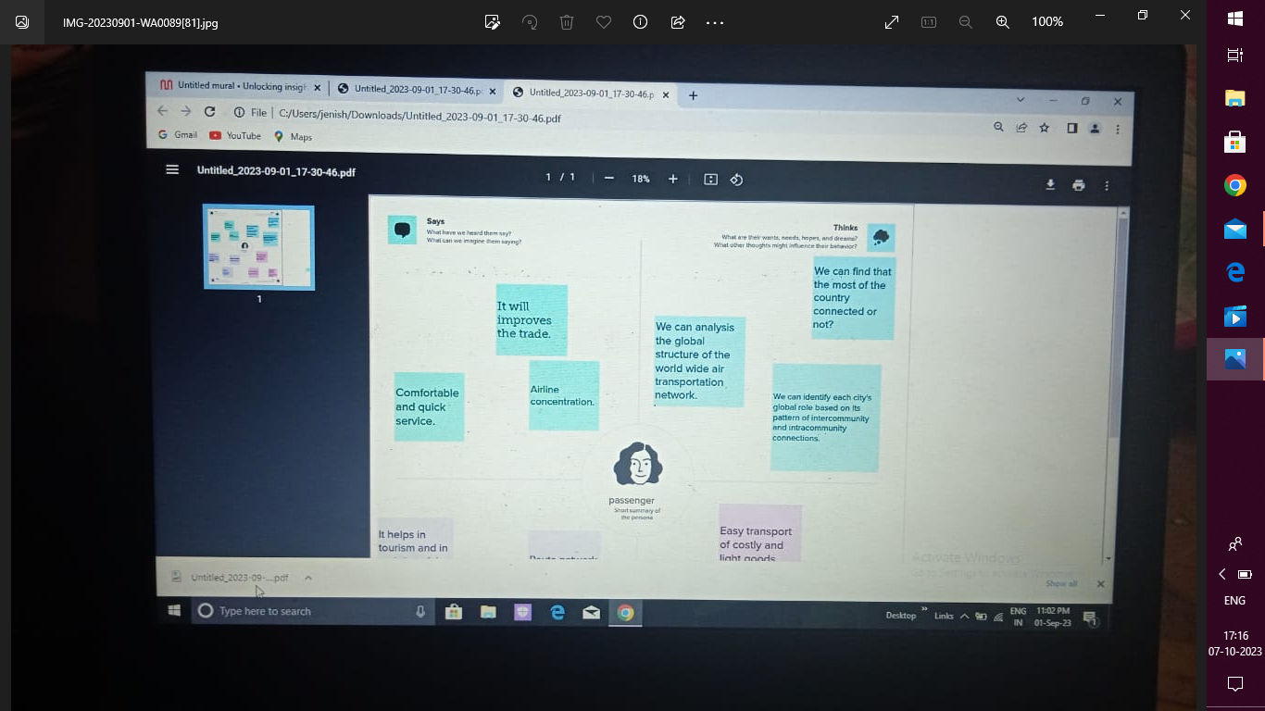

***2.2 BRAINSTORMING MAP***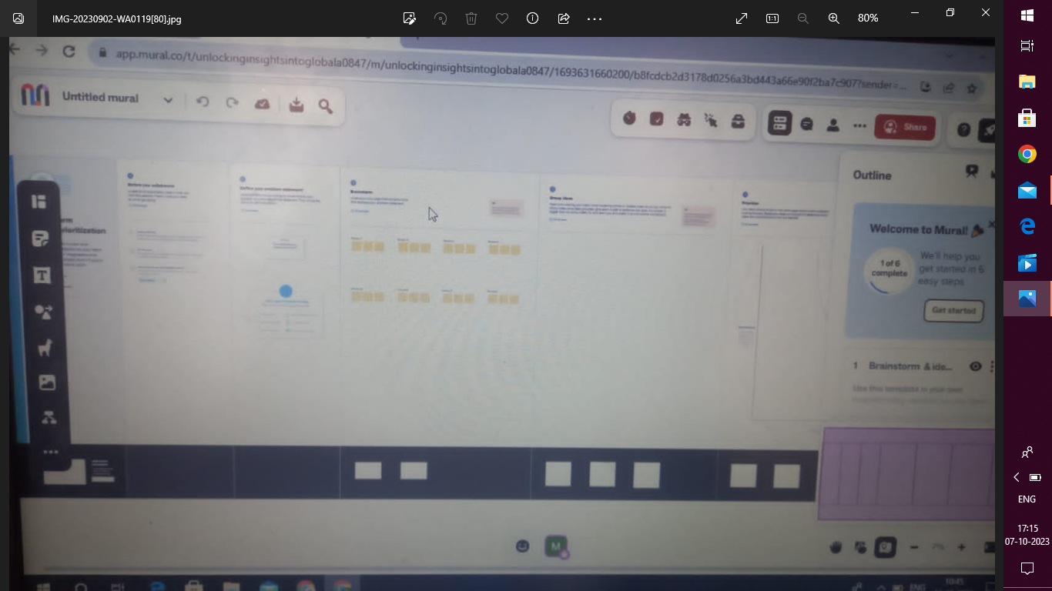

***3.RESULT***

***3.1 DASHBOARD-1***

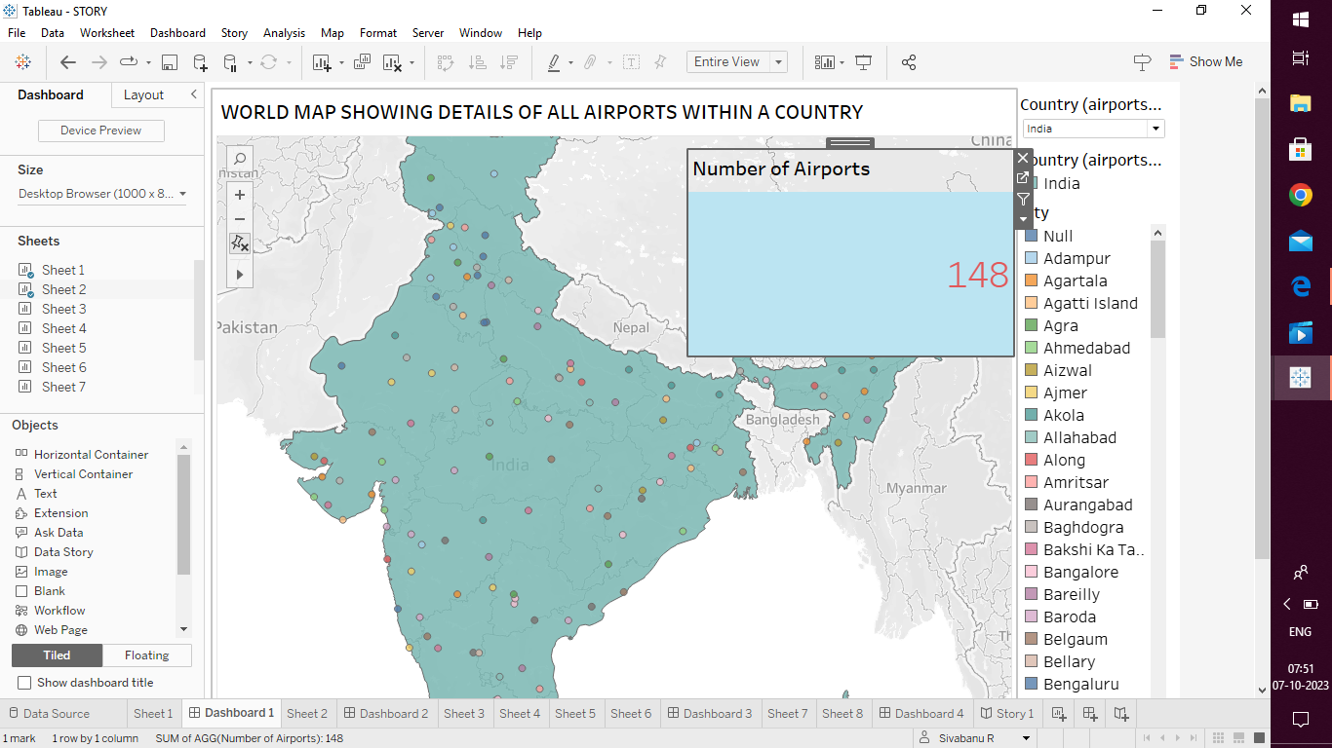

***3.2 DASHBOADB-2***

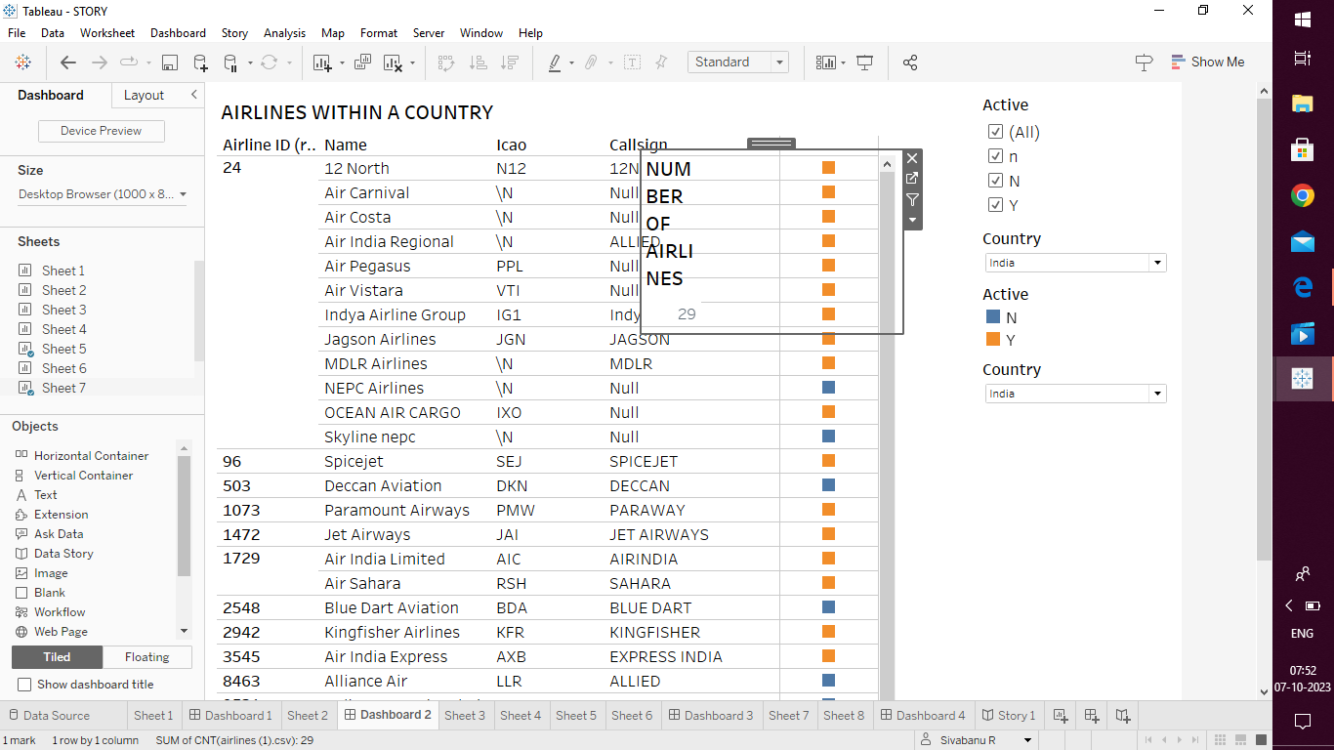

***3.3 DASHBOARD-3***

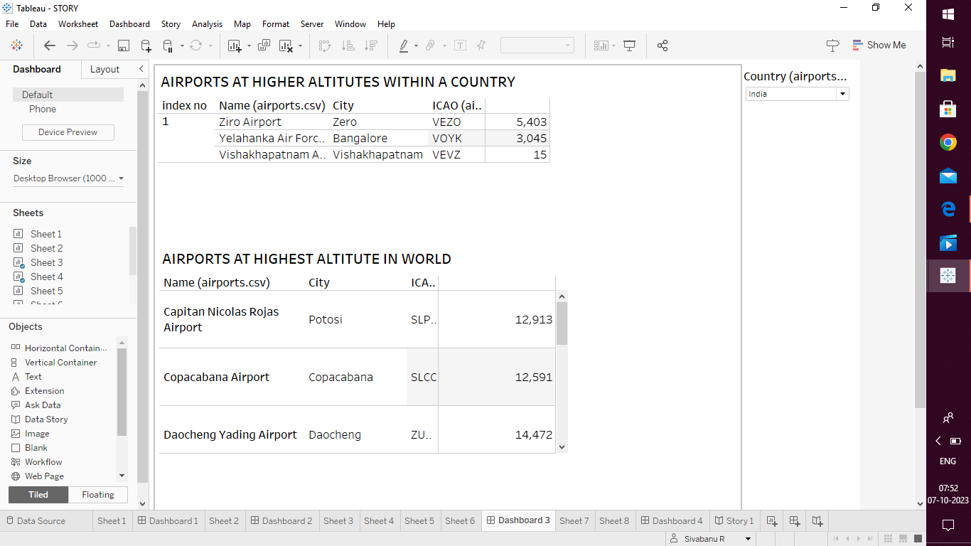

**3.4 DASHBOARD-4**

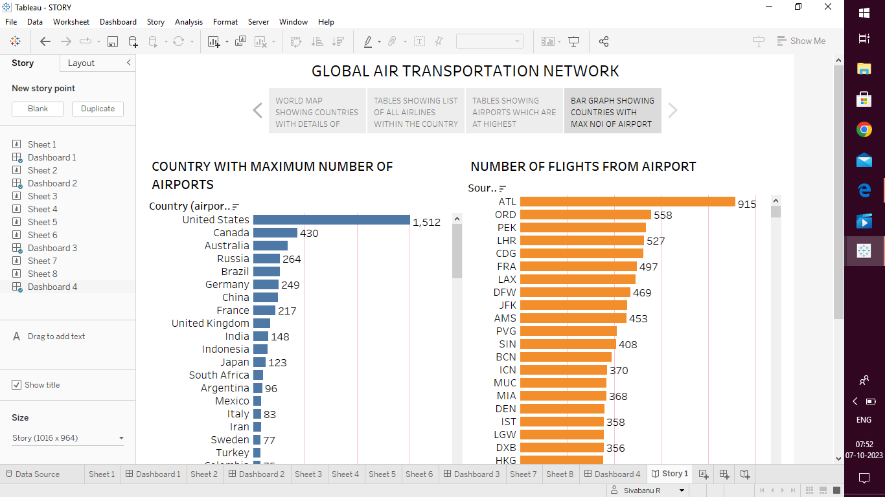

**3.5 STORY-1**



**4. ADVANTAGES & DISADVANTAGES**

*4.1 ADVANTAGES*

*\* DEVELOPING REGULATORY AND ECONOMIC FRAMEWORK*

*\* EXPANDING THE ROUTE NETWORK*

*\* USE OF COMPUTER PROGRAMS TO REDUCE NOISE*

*\* DEVELOPMENT OF LASER BASED AIR DATA SYSTEM*

*4.2 DISADVANTAGES*

*\* AIR TRAFFIC OCCURS*

*\* INEFFICIENT OF FUEL*

**5.APPLICATION**

*WE CAN ANALYSIS THE GLOBAL STRUCTURE OF THE WORLDWIDE AIRTRANSPORTATION NETWORK.*

**6.CONCLUSION**

WE CAN IDENTIFY EACHCITY’S GLOBAL ROLE BASED ON ITS PATTERN OF INTERCOMMUNITY AND INTRACOMMUNITY CONNECTIONS.

**7.FUTURE SCOPE**

EMERGING TECHNOLOGIES ARE RESHAPING WITH ROBOTICS, ARTIFICIAL INTELLIGENCE, THE INTERNET OF THINGS, UNMANNED AIRCRAFT SYSTEMS AND THE PUSH FOR HYBRID AND ELECTRICAIRPLANES.

THE END.........